Business process and structure for smeS

SMEs are regarded as Small and Medium-Scale Enterprises. According to Vanguard - “SMEs are now strategic and essential for accelerating economic growth in Nigeria and they constitute about 90% of all Businesses in Nigeria, creating more than 80% of employment in the region”...SMEs are gradually creating a growing middle class with disposable income, in relation to market opportunities for new investors.

From Research and Deduction, I can categorically say that 4 out of 10 SMEs started up as “hustles”; alternatives to 8-5 employments (as Unemployment and Unemployability are major challenges in Nigeria) Hence, there has been no prior planning

No Business can be Sustainable without Due Processes and Structure

ILLUSTRATION

Chuka is a 27 year old first class graduate of Information Technology, highly skilled in Software Development, Programming, and UI/UX Designing. All he has ever wanted the most was to start a technology hub which develops applications that solve FinTech problems.

He teamed up with 3 IT Interns and he built his first app that could solve a number of issues associated with Online and SMS Banking, he tirelessly worked on this project as he saw it as the perfect opportunity to pitch to investors . If he achieved that, his Technology Hub would be a reality!

His perfect pitch opportunity came, but he was not prepared for it. An Initiative that funded start ups invited him to a dinner with Investors and he had some minutes to “drop” his elevator pitch! He was asked a number of questions that he had no answers to!! The prospective investors dismissed him on the note that ; “He was not ready”!

QUICK ASSESSMENT



It is no news that the invention of Digital Marketing has been both beneficial and distracting, as the case may be. My experiences with small businesses and vendors have afforded me a wealth of experience and practical situations. There have been instances where business owners focus on social media marketing alone, with no consideration for other marketing channels.



Credit;

Pexels

To determine what marketing channels would work best for you, you should first Identify who your clients are!

I will be sharing a few scenarios and instances with you, to enhance your understanding of the tips that will be enumerated in this material.

**SCENARIO A: EMEKA THE SHOE MAKER**

Emeka acquired the skill of making bespoke shoes from a Skill Acquisition Program that was powered by The Shapers Initiative, and he specifically focused on school shoe designs for children between the age of 3 - 16years.

He set up Instagram and Twitter accounts, as two platforms where he would market his shoes. After 8 months, Emeka sent a report to the NGO that sponsored his training and he complained bitterly about how sales have been terribly low. As a Consultant with the NGO, Emeka was referred for a session with me and we had this conversation after he had shared his Business Challenges with me;

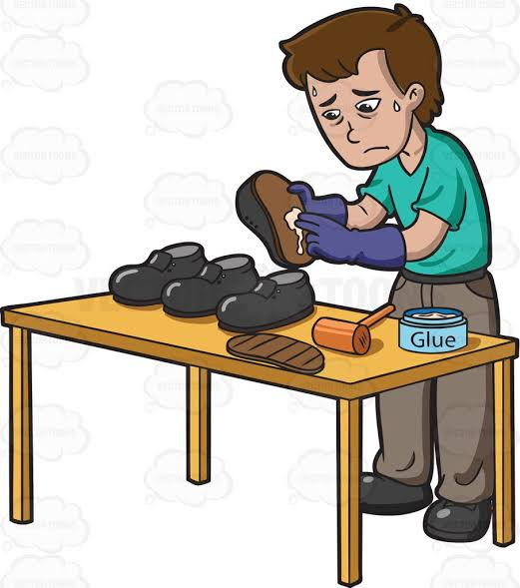

Photo - Shoe Maker Clipart

Credit - Google

**ME - WHO ARE YOUR TARGET CLIENTS AND WHERE DO YOU THINK THEY CAN BE FOUND**?

**EMEKA - WELL..., CHILDREN WEAR THE SHOES AND THEY HAVE PARENTS THAT HAVE SOCIAL MEDIA ACCOUNTS. THAT'S WHY I'M ON TWITTER AND INSTAGRAM..**

**ME - OKAY(WITH A RAISED EYEBROW) HOW ABOUT HOW YOU REACH ANOTHER CATEGORY OF CLIENTS, OFFLINE PERHAPS.**

**EMEKA - HA MADAM, THE WORLD HAS GONE DIGITAL O. INFACT I SENT EMAILS TO SOME SCHOOLS TO ASK IF I COULD SUPPLY SCHOOL SHOES AT SUBSIDIZED PRICES THAT THEY WILL SELL WITH SCHOOL UNIFORMS.**

**ME - GREAT IDEA! HOW MANY OF THEM RESPONDED?**

**EMEKA - NOBODY YET O, MAYBE THEY ARE NOT READY JOR!**

**ME - DID YOU SEND REMINDER EMAILS?**

**EMEKA - SEE MADAM, I CAN NOT KILL MYSELF AND FORCE THEM TO BUY.**

Now, let's analyse that conversation I had with EMEKA.

1. His Target Clients Online can not only be found on Twitter and Instagram.

Parents know what they want to buy for their children and they first visit online platforms where they are certain that vendors are verified - Jumia, Konga, SME Market Hub, Jiji...etc...So I will ask you this question -

**WHAT OTHER ONLINE PLATFORMS ARE YOU MARKETING YOUR PRODUCTS APART FROM SOCIAL MEDIA?**

2. He should have considered Offline Marketing channels too.

As digital-oriented as organisations are becoming, some organisations are still laid back at it. Some school websites have not been updated in at least 2years. Hence the contact details you see there may no be valid. Which is why a visit to Schools with hard copy letters or proposals would have been a better way of communicating with them; meeting a contact person and possibly getting a functional phone number or email to follow up with.

**HOW WELL DO YOU UNDERSTAND YOUR TARGET CLIENTS AND HOW TO COMMUNICATE WITH THEM? IF YOU ARE SELLING A PRODUCT THAT A SICK 85YEAR OLD MAN NEEDS, YOU WILL NOT FIND HIM ON TWITTER!!!**

3. Emeka sure needs to upgrade his communication game.

Sometimes emails go to spam, especially If it's coming from an unrecognized address and we often miss such emails. More importantly a follow up email would have sufficed.

**DO YOU GIVE UP AS SOON AS A PROSPECTIVE CLIENT GOES MUTE ON YOU, OR YOU DUST YOUR HAT AND BE THE JOLLY CUSTOMER SERICE OFFICER THAT FOLLOWS UP**?

**EXERCISE 1**

|  |  |  |
| --- | --- | --- |
| **QUESTIONS** | **RESPONSES** | **NOTES** |
| **WHAT PRODUCT/SERVICE DO YOU SELL?** |  |  |
| **WHO ARE YOUR TARGET CLIENTS?** |  |  |
| **WHERE CAN THEY BE FOUND?** |  |  |
| **WHAT ARE YOUR MARKETING CHANNELS?** |  |  |
| **ON WHAT CHANNEL DO YOU HAVE THE MOST COMPETITORS?** |  |  |

Another challenge that small businesses have is with their pricing. The euphoria of screaming "Sold" has made a lot of vendors unrealistic, as they often sell products at the Cost Price! How does any Business survive without profit? I have heard so many excuses that I find unbelievable myself!



Balance Scales

Credit - Google

Certain things have to be considered before fixing retail price on your product or service;

**1. YOUR COST PRICE**

**2. LOGISTICS**

**3. YOUR PROFIT**

**SCENARIO B: AJOKE AND AISHA THE PERSONAL SHOPPERS**

Ajoke and Aisha are both vendors on Instagram with fair following.

Ajoke buys beautiful designer copy bags from Eko Idumota, while Aisha shops for Original Susen Bags from the US. Anytime Aisha sees Ajoke put up "SOLD" on an item, she wonders how Ajoke is able to move such beautiful looking bags in pictures at ridiculously cheap prices, while her own sales are slow or gradual at best.



Photo ;

Shopping Girl Vector

(Credit - hanslodge)

She had no idea where Ajoke got her bags from and she was oblivious to the fact that they were copies, because Ajoke always put up high resolution stock images of the bags she sold. In a quest to join the SOLD OUT gang, Aisha did a price slash and sold below her cost price. She said all that mattered to her was turn over. After a month, She looked through her books and realized she had sold out 20 bags but the inflow could barely cover the cost of 9 Handbags!!!!

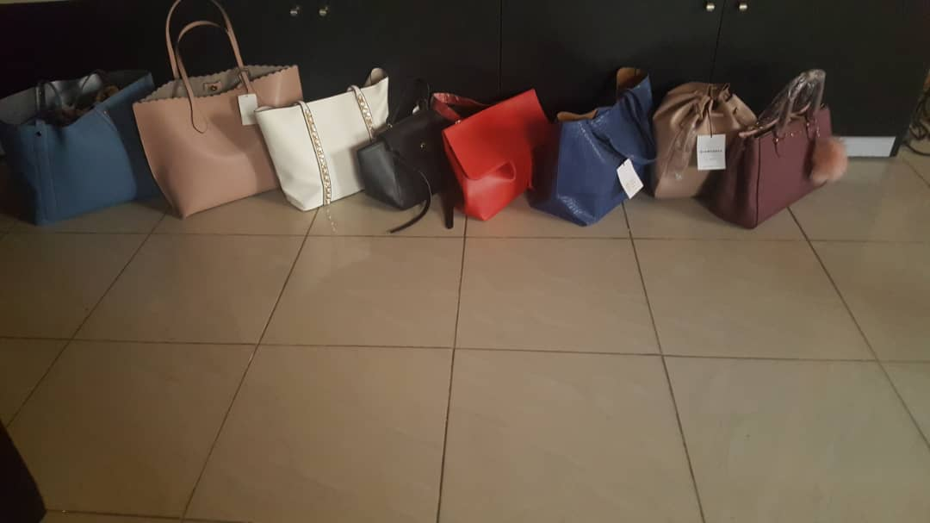

Photo ;

Styled By Mobsy

1. Aisha clearly did not understand her product, products like it and the backstage gimmicks in her line of Business.

Businesses have shut down because there was no proper survey or clear understanding of it. Also you have to be confident of your product and its value!

**HOW MANY TIMES HAVE YOU SLASHED YOUR PRICES BELOW COST PRICE, JUST BECAUS YOU WANTED TO DISPLACE YOUR COMPETITIORS?**

2. Aisha did not consider the logistics she incurred on shipping in her goods, else with that alone she should know that their pricing could never be the same.

**DO YOU FACTOR IN THE COST INCURRED ON LOGISTICS BEFORE FIXING YOUR SELLING PRICE?**

3. If Aisha continues running her business like that, how long do you think her business will last?

**EXERCISE 2**.

|  |  |  |
| --- | --- | --- |
| **QUESTIONS** | **RESPONSES** | **NOTES** |
| **DO YOU CONSIDER YOUR LOGISTICS &PROFIT BEFORE FIXING YOUR SELLING PRICE?** |  |  |
| **WHAT PERCENTAGE OF YOUR COST PRICE DO YOU CONSIDER AS FAIR PROFIT?** |  |  |
| **IF YOU PROVIDE A SERVICE, HOW WELL DO YOU UNDERSTAND THE BUSINESS OF YOUR CRAFT/SERVICE?** |  |  |
| **HOW OFTEN DO CLIENTS NEED YOUR PRODUCT OR SERVICE?** |  |  |

The essence of these exercises is to enable you assess your marketing and your pricing. Getting these two right is very crucial to your making sales and sustaining your supply, as well as your Business. The goal is to transition your Business from being a hustle to an actual enterprise that will eventually grow into a Global Brand, and to get to that end point, there has to be commitment and seriousness in ensuring that these tips are well implemented in your Business.

If you need further clarification in your specific circumstance or business, feel free to send an email to - info@projectpreneur.com.ng